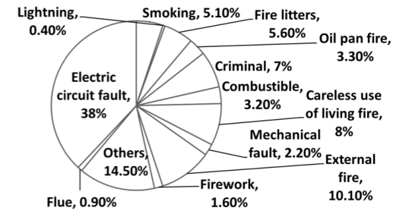

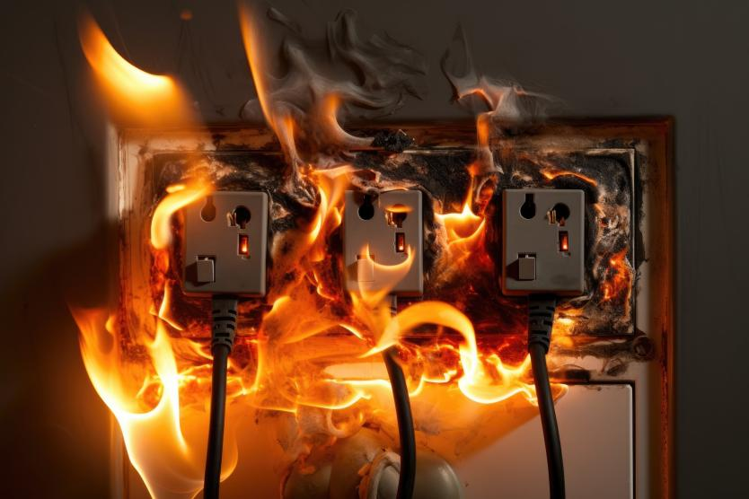

Keyword:

Automatic induction, intelligent prevention, independent fire extinguishing, maintenance free

Safe/Reliable/Firefighting/Cooling

Space temperature ≥ 80 ℃, automatic release of fire extinguishing gas, automatic fire extinguishing

No power supply required, no smoke or temperature detectors required

No need for complex equipment and pipelines such as high-pressure steel cylinders

No need to maintain long-term protection with a validity period of 10 years

Compact size/Space saving/Strong magnetic design/One second installation

Iron magnet design

Currently, the fire protection industry has a wide variety of categories, but the quality is uneven, and there are also many cheap but counterfeit products. To address this pain point, the research team has developed and produced this high-tech new type of fire extinguishing product, mainly used for electrical appliances such as distribution boxes, transformers, switches, sockets, etc. that are relatively sealed and prone to ignition and cause significant losses.

Size: 5X2.5 cm comes with a strong magnetic device

Due to its small size, it is not affected by any position and can be placed in various narrow and complex flammable spaces and equipment. This feature compensates for the shortcomings of existing fire protection products that cannot extinguish such fire sources.

Small in size, it can be directly installed inside protected electrical equipment and placed at the highest point where short circuits, overheating, or arc sparks are prone to occur. Targeted protection is provided for areas prone to electrical fires.

According to application requirements, it is designed with a magnet for easy installation, without the need for additional tools or professional installation personnel. It can be easily installed with just one suction.

The product is as small as 5cm \* 2.5cm and 2cm \* 1cm, making installation very convenient. It uses the principle of strong magnetism to directly stick the product onto flammable electrical appliances. Very convenient. It can attach to flammable products within 1 second.

--------------------------------------------------------------------

Fire extinguishing principle:

Breaking through traditional fire extinguishers, this intelligent fire extinguishing device will overturn the tradition of the fire extinguishing industry and completely change the fire extinguishing principle. This is a new species. Its working principle is also very magical. When the ambient temperature exceeds 80 degrees Celsius, the FIRE Source STOP will automatically activate and release extinguishing gas to directly extinguish the surrounding open flames. Fire extinguishing gas is a physical fire extinguishing agent called perfluorohexane, which achieves fire extinguishing through cooling. The fire extinguishing agent releases vaporized gas and forms a gaseous mixture with air. The heat capacity of this mixture (heat capacity refers to the amount of heat absorbed or released when an object is heated or cooled) is much larger than that of pure air. It can absorb heat from flames and fuel, lower the temperature below the minimum temperature that can maintain combustion, and achieve rapid fire extinguishing. What's even more surprising is that this intelligent fire extinguishing device can be reused. After extinguishing the open flame, as long as the object has not yet evaporated, it can still be used again. After all solid volatilization is completed, it will terminate. With it, you no longer need to worry about fires in household appliances.

Ecological and Environmental Protection, Zero Safety Hazards:

The gas used in the FIRE SOURE STOP is perfluorohexanone, which is very environmentally friendly and does not harm the human body at all.

No harm to human body

No pollution to the environment

No secondary damage to equipment

Fire extinguishing gas is environmentally friendly and can decompose quickly under the action of ultraviolet radiation. Its residual time in the atmosphere is 3-5 days, and its GWP value is about 1. Due to its absence of bromine or chlorine, it will not cause damage to the ozone layer (ODP value is 0). This environmental performance is unmatched by any fire extinguishing agent in the world today, and it also ensures the long-term use of fire extinguishing gas. The fire extinguishing efficiency of the FIRE SOURE STOP is high, with a designed fire extinguishing concentration of 4-6% and excellent fire extinguishing performance.

The acute toxicity test showed that the FIRE SOURCE STOP fire extinguishing gas is a non-toxic product. Through the analysis of the experimental results, it was determined that the concentration of invisible harmful effects of the FIRE SOURCE STOP fire extinguishing gas on carcinogenesis, 4H acute inhalation, and other acute inhalation is 10%, with a safety margin of 67-150 (the safety margin of Halon1301 is 0, the safety margin of CO2 is -70, and it is lethal during concentration testing). FIRE Source STO gas is much less non-toxic than fluoroalkanes and has been approved by the US Environmental Agency for use in human environments.

Toxicity test results of fire extinguishing gases：

Experimental Project Experimental Results

Acute inhalation can actually be considered as the five toxins (LC5.0>0.01)

Carcinogenic and non carcinogenic (NOAEL: 0.1)

Low acute oral toxicity (LD50>2000mg/kg)

Low acute skin toxicity (LD50>2000mg/kg)

Mild irritation to the eyes

No skin irritation

No allergic effects on the skin

Paule negative

Chromosome aberration negative

28 day inhalation study, concentration of invisible harmful effects (NOAEL: 0.004)

Application field details(Expensive, Relatively small and enclosed spaces)：

1. Computer/communication room, electrical control room, precision instrument room, physical and chemical laboratory, electrical aging room;

2. Motors, transformers, distribution boxes, sockets, switches, and places prone to electrical fires.

3. Wind power generation, engine, trigger rolling machine, printing machine, dip tank, spraying equipment, spray setting;

4. Oil extraction platform. Gas stations, hydraulic oil depots, lubricating oil depots, and other flammable and combustible fluids;

5. Chemical flammable material storage, as well as production and operation fire hazard sites for such substances;

6. Library, database, archive, film library, vault, and cultural relic collection library;

7. Airport maintenance work area, aircraft crash rescue, military system combat vehicles, and warships.

8. Cooling and extinguishing of energy storage batteries

It can also be used for flammable new energy vehicles, electric vehicles, big data computer rooms, distribution boxes.

Product size and application:

Fire extinguishing types: Class A fire, Class B fire, Class C fire, Class E fire

Class A fire: solid organic matter, wood;

Class B fire: liquid, soluble solid, gasoline, wax;

Class C fire: gas;

Class E fire: refers to the fire caused by charged objects and precision instruments

Protection volume 8L, starting temperature 80 ° C

Validity period of 10 years Product model SL5X2.5cm

SL5X2.5cmA comes with a strong magnetic device, which can be placed directly above the ignition point of metal materials that are prone to fire

According to various environmental technical requirements, place the fire extinguishing source above the ignition point that is prone to fire, which is safer.

Fire source spray extinguishing for more than 10 times, gas total submergence extinguishing for 1.2 liters

Product size: 25mm x 50mm x 3mm

SL5X2.5cmB comes with a 3m backing adhesive and is a specialized product for plastic wall socket switches. It is installed on the top of the inside of the box

1 piece per power socket

Fire source spray extinguishing for more than 10 times, gas total submergence extinguishing for 1.2 liters